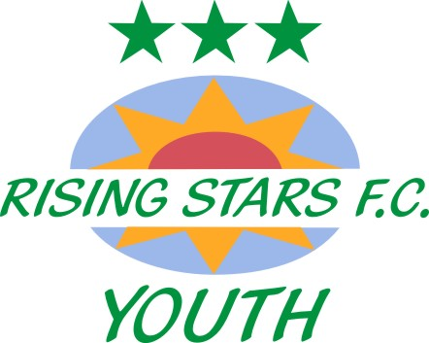
Club Secretary: Kathryn Derby 29 Wynn Road Whitstable Kent CT5 2JP
M: 07900 892393 E: risingstarsyfc@gmail.com

Club complaints procedure

In the event that any member feels that he or she has suffered discrimination in any way or that the Club Policies, Rules, or Respect Codes of Conduct have been broken by another member of the Club, the procedure for making a complaint is as follows.

1. Report the matter immediately, in writing (sent by email or posted letter), to the Club Welfare Officer or Club Secretary.

Your report should include:
- Details of what, when, and where the incident took place
- The names of any witnesses to the incident
- Names of any other Club members who have been treated in a similar way
- A preference for a solution or outcome to the incident you are reporting
- Your name and preferred contact details.

2. The Club may request further information from the complainant and/or witnesses or other Club members before any review of the incident can be undertaken.

3. The Club will acknowledge receipt of any written complaint within 48 hours by telephone or email.

4. The Club will respond to any written complaint it has received within 10 working days by telephone or email.

5. The Club will follow its Disciplinary Procedure where it is warranted in relation to the complaint raised. The Club is not required to share the outcome of any Disciplinary Procedure with the complainant.

6. If a complainant is unhappy with the outcome of their complaint, they can appeal to the Club’s Committee or Chairman.

7. The outcome of any appeal made by the Club is final.

8. If the complaint is regarding a member of the Club’s Committee, the complainant has the right to report the incident or request guidance on the incident from the County Football Association (www.kentfa.com).

