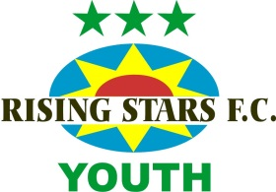
Club Secretary: Kathryn Derby 29 Wynn Road Whitstable Kent CT5 2JP
M: 07900 892393 E: risingstarsyfc@gmail.com

Club ethos and mission statement

Sporting behaviour and social skills, fitness and fun!

We are an inclusive club that fosters teamwork, with an emphasis on participation and involvement by players, coaches, officials, parents and carers. We work with boys and girls of all abilities from the age of 7.

We aim to build children’s self-esteem and confidence, giving them a safe and structured environment in which to develop their football and interpersonal skills. We empower children to work to the best of their ability and to reach their potential.

- We have high expectations for children’s and adults’ behaviour and set clear boundaries.
- We put into practice the principles enshrined in the Football Association’s Respect campaign, Equality Policy and Child Safeguarding Policy.
- We do not exclude any child due to learning or behavioural difficulties.

Our focus:
- engagement and attitude to learning
- personal, social, thinking and leadership skills
- behaviour and safety
- aspirations and achievement
- fun

We want children to play with a smile on their face

and to play as a TEAM (Together Everyone Achieves More)

